

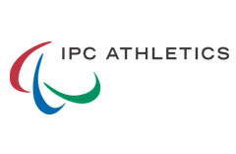





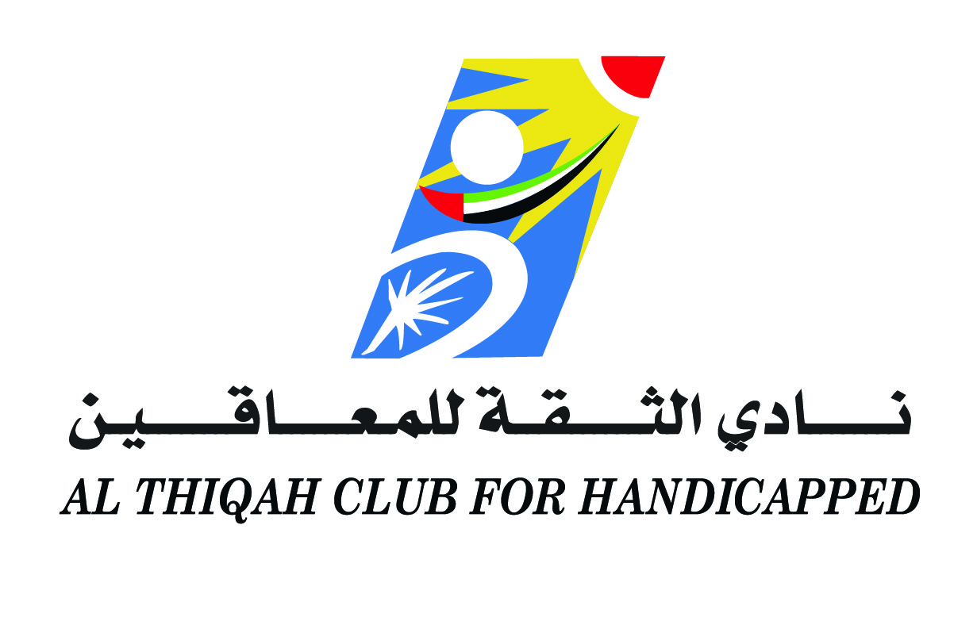

**Participant Declaration Form**

*Agreement, Waiver, Release & Acknowledgement*

On acceptance of this entry, I hereby for myself, my heirs, executors and administrators waive and release any and all rights claims for damage I have or may have against Althiqah club for handicapped, the sponsors and all organizers and successors (LOC) that may arise as a result of my participation in the 6th Sharjah International Athletics Meeting to be held 14th and 15th March 2016 (Competition), at Sharjah, United Arab Emirates and training camps in Sharjah City during the year 2016.

I attest and certify that I am physically fit and have sufficiently trained for the competition of this event and my physical condition has been verified by a licensed medical doctor in my country. I agree to abide by all rules and regulations of Althiqah club for handicapped, and IPC. further, I hereby grant full permission to any and all of the foregoing to use my photographs motion pictures, recordings, or any other record of this event for any legitimate purpose including commercial advertising.

Note:

Athletes participating in the 6th Sharjah International Athletics Meeting 2016 could be subject to drug testing, according to IPC and WADA rules. The participation in the competition will be considered as an acceptance to drug testing and publication of the results to the concerned parties. Athletes found positive for banned substances will be disqualified from this event and may lose eligibility for future competitions.

Athletes who wish to have any training on the road outside the training sessions previewed by the LOC will do that on their own responsibility and there will be no escort for them.

(NB: Parents or legal guardian will sign for participants under 18 years.)

Athlete's Full Name: ………………...…………….……………………………………………………… Country/NPC:

…………………..........................................……………………………………..

Date: Signature:

**Must be returned to the organizing committee no later than: 25th February 2016**

**Fax: +971 6 5389888; Email:** [**althiqah@emirates.net.ae**](mailto:althiqah@emirates.net.ae)